**Task 1: Feature point**

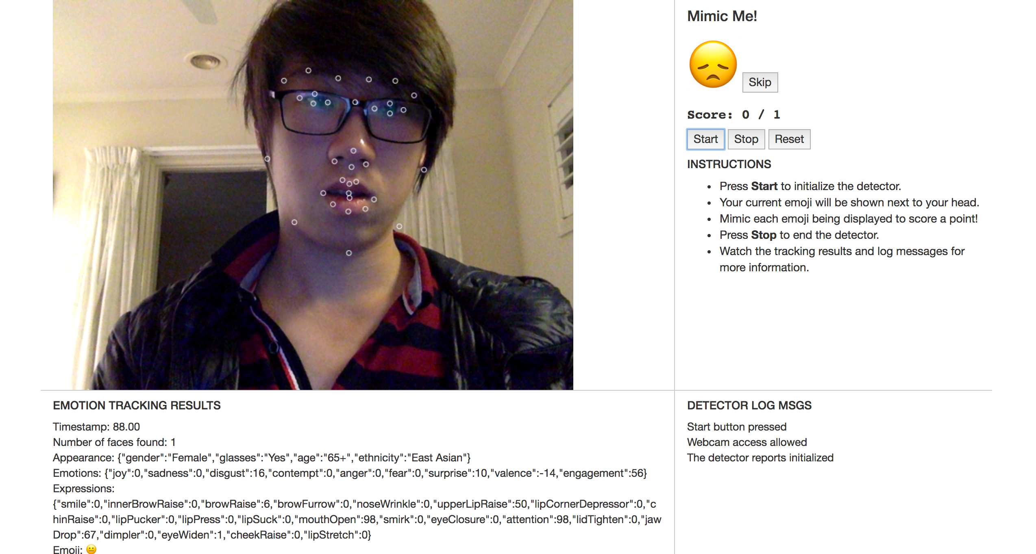

For this task, I extract the x and y coordinates from the face.featurePoints property, then draw them using ctx.arc() with white stroke.

**Task 2: Dominate Emoji**

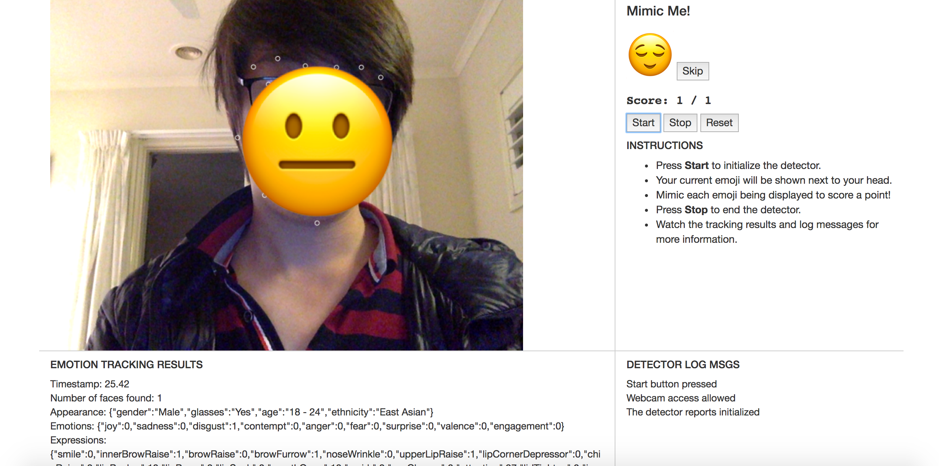

For this task, I calculated the centre anchor of the emoji by averaging out the sum of all x coordinates and y coordinates. Also, I calculated the font-size (in this case the vertical height of the emoji) by choosing the difference of the max and the min y coordinates.

**Task 3: Game implementation**

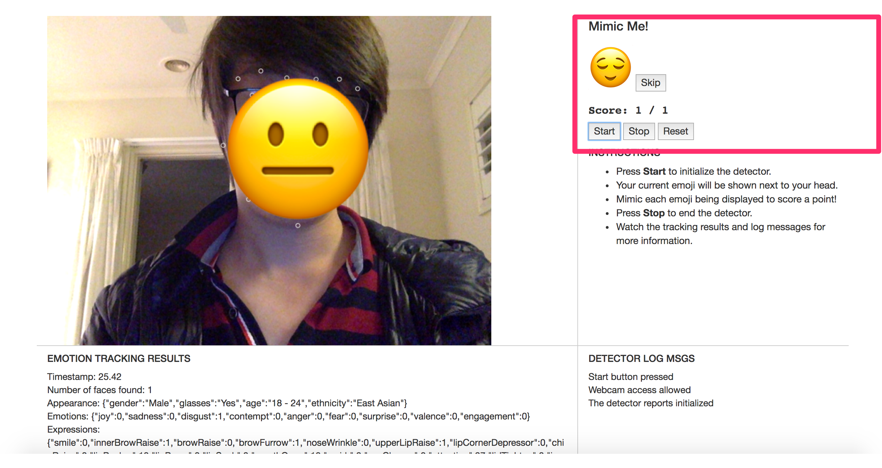

For the game implementation, I added the respective setTargetEmoji() with chooseRandomEmoji() and update functions in respective event listeners. I stored the current score, total score and current emoji as variables through the game, by default, there are ten rounds. Furthermore, I found out sometimes it’s a bit hard for me to mimic some emojis, so I added a Skip button to pass the current one and jump to next one.